INTRODUCTION

Taxonomy
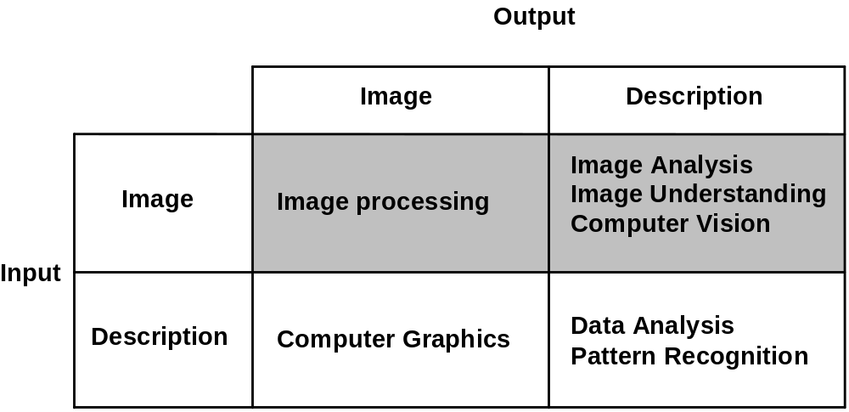

Image processing
scope: to form a digital image (from 3-dimensional scene to 2-dimensional image), to transform one 2D image into another.
aims: digitisation, enhancement (for human viewing and also for subsequent computer processing), simple object extraction
examples: remove warps or distortions, remove blur, smooth speckle or noise, improve contrast or other visual properties

Image analysis and image understanding
scope: to obtain information from 2-dimensional image and about 2-dimensional image (rather than about 3-dimensional scene that it represents)
aim: derive descriptions of the image contents
examples: finding properties of the image or its parts (e.g. size, shape of image objects), finding key structures in the image (e.g. edges or regions of similar brightness),

Computer vision
scope: to obtain information from an image (or a set of images) about 3-dimensional scene that the image(s) represents
aim: derive meaningful and usable descriptions of the scene depicted in the image(s)
examples: object sorting and picking by robots, object tracking, vehicle guidance, obtaining diagnostic information from medical images, face recognition, inferring object distance, inferring spatial relationships between objects, event description

Human visual perception

Knowledge about a human visual system can be very useful to the designer of 'engineering' type of applications and understanding tasks.

It is crucial in the modelling approach.
When pictures are intended for viewing by humans, to carry out image processing appropriately we need to understand:
- how to assess subjective quality of an image
- how to ensure the required fidelity of a picture to an original scene
- the nature of the “weak spots” of the human visual system

When image is to be analysed for purposes of image description, we need the knowledge of the human perception so that:
- parts extracted through image analysis correspond to those seen by humans
- parts can be described in terms used by humans

When developing computer vision systems for a particular purpose:

- the human visual system is a good model

it works!

Human visual system

The eye

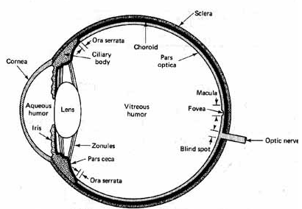

The brain
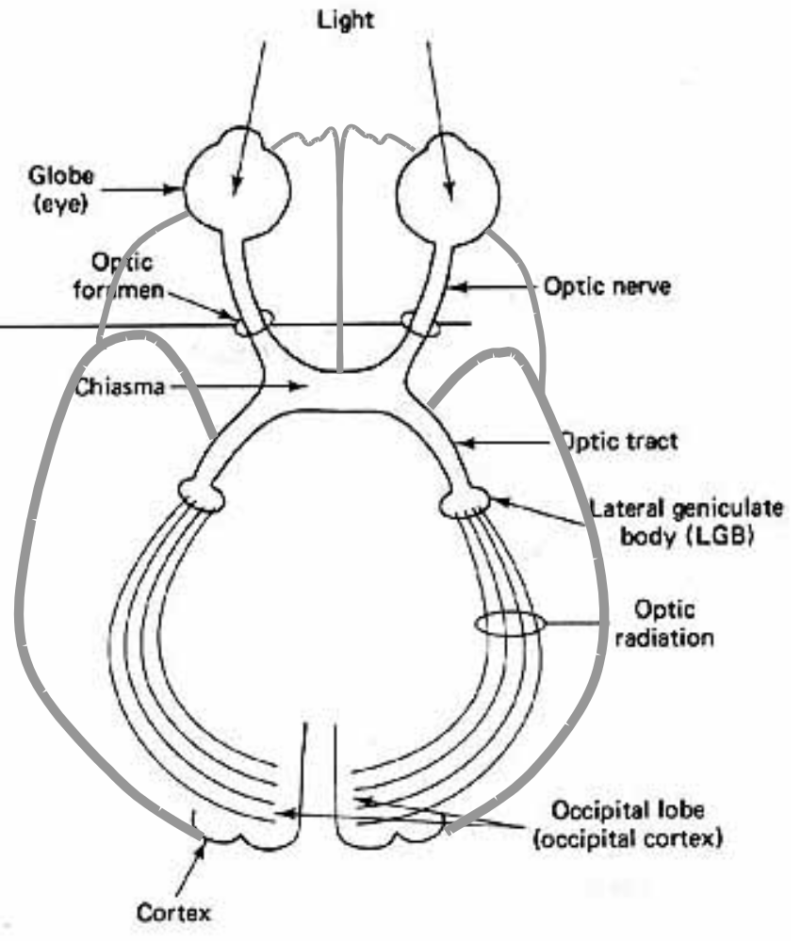
Retina - receptors and optic nerve

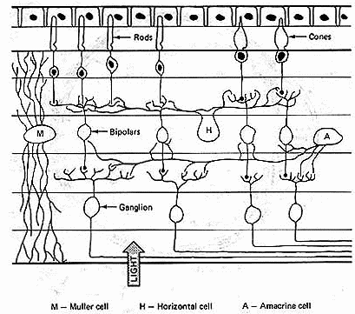
Retina - receptors and optic nerve

• rods sensitive to light and motion, off centre, 120 million
• cones detect detail and colour, central, 6 million
• fovea is packed with cones, uniform resolution, 2000

Stereo

• Two eyes look at the scene with angular separation of about 5 degrees.
• Convergence of two eyes changes with distance.
• Two eyes move together: they search for the target in saccades and converge together to focus.
• Each eye receives a slightly different view of the scene; this is called disparity and enables to perceive depth in the scene.

Vision

Vision is an “intelligent” process, it is

• active
• purposeful
• creative

Perceptual phenomena
Luminance and perceived brightness
Mach bands



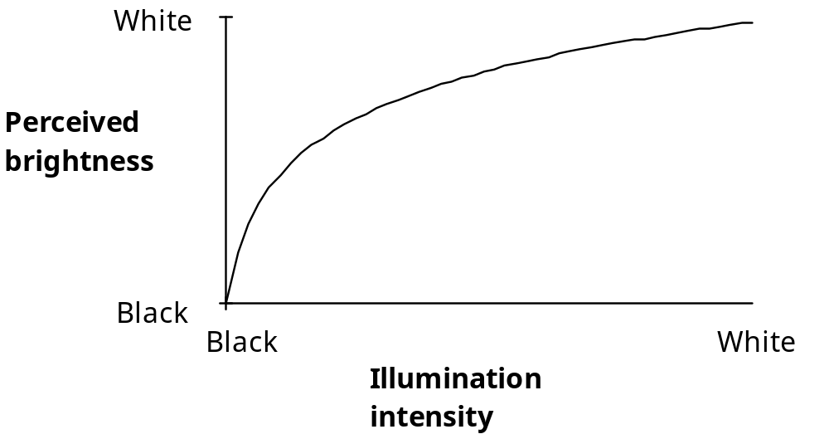

Simultaneous contrast



Kanizsa triangle

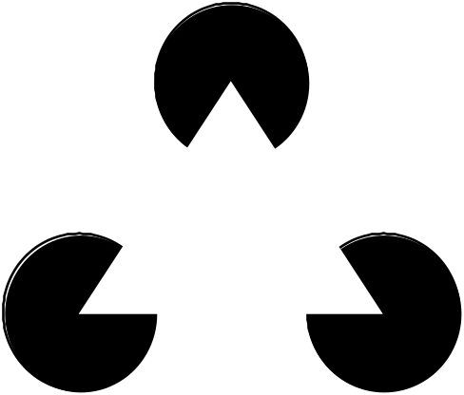

Relative size

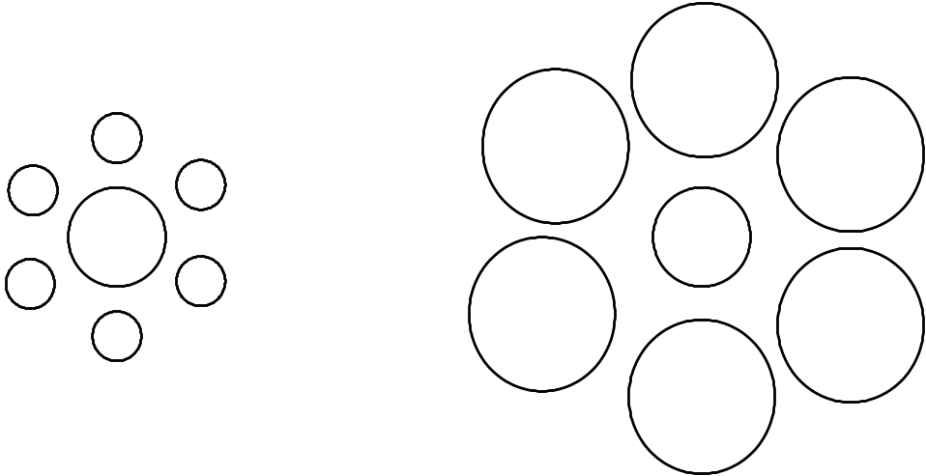

Perceptual grouping
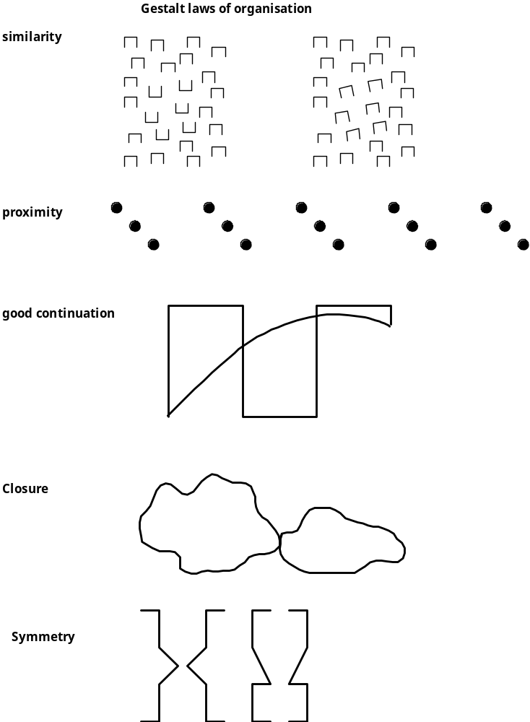

Recognition



Digital image

Source:
cameras, range scanners, directly from instruments

Physical signal:
light intensity, range, X-rays, ultrasound, infrared, microwave . . .

Simple tools for examining digital images

- Pixel value
- Line profile
- Histogram
- Thresholding

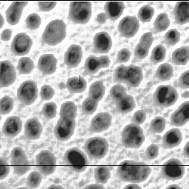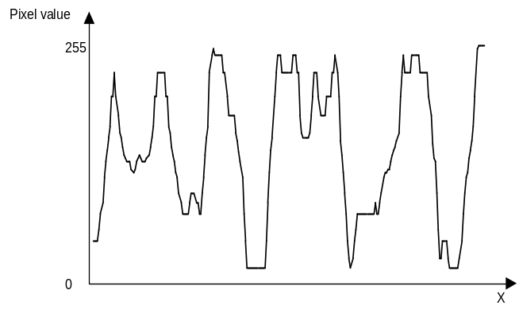

Thresholding

I’(x,y) = 0 if I(x,y) < T

I’(x,y) = 1 otherwise

